[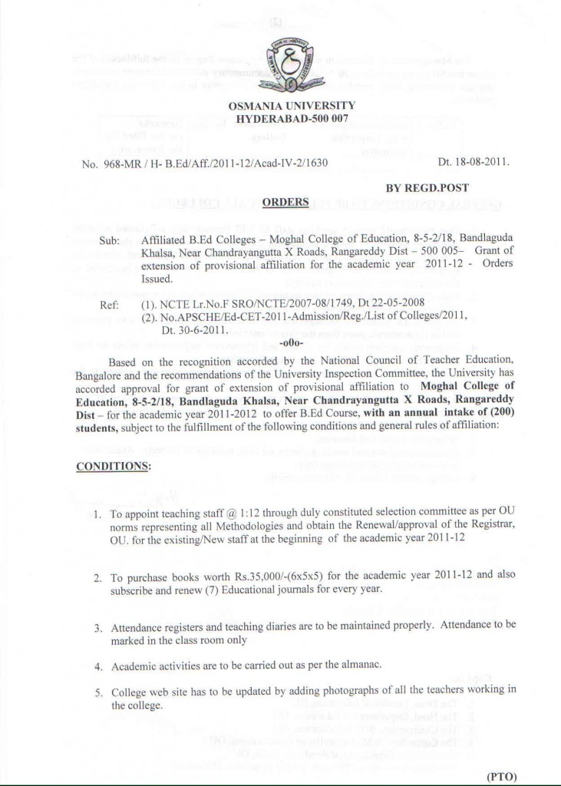](http://moghalcollege.org/wp-content/uploads/2011/11/ORDER1.jpg)

[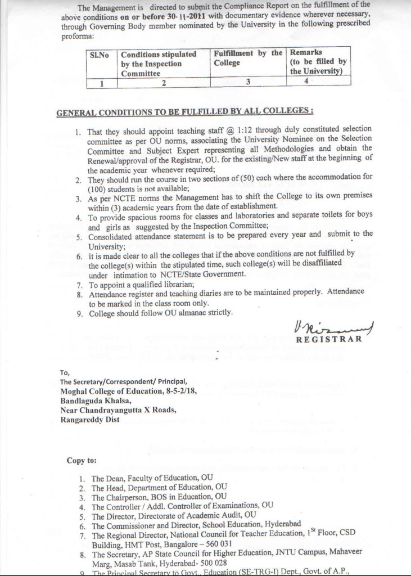](http://moghalcollege.org/wp-content/uploads/2011/11/ORDER11.jpg)